21BDS0340

Abhinav Dinesh Srivatsa

Operating Systems Lab

Assignment – IV

**Question 1**

* First Fit

Code:

#include <iostream>

using namespace std;

int main()

{

// getting input

int n, m;

cout << "Enter number of blocks available: ";

cin >> n;

cout << "Enter number of processes: ";

cin >> m;

int *block = new int[n], *process = new int[m];

for (int x = 0; x < n; x++)

{

cout << "Enter block size " << (x + 1) << ": ";

cin >> block[x];

}

for (int x = 0; x < m; x++)

{

cout << "Enter process size " << (x + 1) << ": ";

cin >> process[x];

}

bool assigned = false;

for (int x = 0; x < m; x++)

{

assigned = false;

for (int y = 0; y < n; y++)

{

if (process[x] <= block[y])

{

cout << "Process " << (x + 1) << ", size " << process[x]

<< ": allocated to block " << (y + 1) << " of size " << block[y]

<< "\n";

block[y] -= process[x];

assigned = true;

break;

}

}

if (!assigned)

cout << "Process " << (x + 1) << ", size " << process[x] << ": Not allocated"

<< "\n";

}

}

Output:

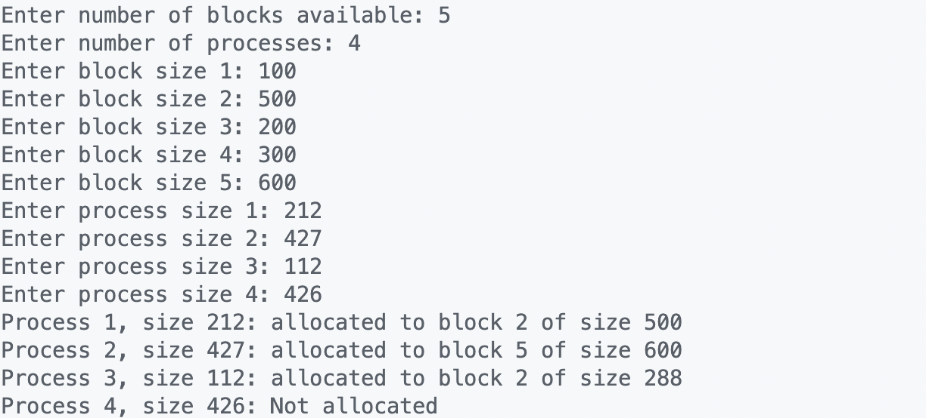

* Best Fit

Code:

#include <iostream>

using namespace std;

void swap(int *x, int *y)

{

int temp = *x;

*x = *y;

*y = temp;

}

void sortAscending(int n, int *array)

{

int length = n;

for (int x = 0; x < length - 1; x++)

for (int y = x + 1; y < length; y++)

if (array[x] > array[y])

swap(array + x, array + y);

}

int main()

{

// getting input

int n, m;

cout << "Enter number of blocks available: ";

cin >> n;

cout << "Enter number of processes: ";

cin >> m;

int *block = new int[n], *process = new int[m];

for (int x = 0; x < n; x++)

{

cout << "Enter block size " << (x + 1) << ": ";

cin >> block[x];

}

for (int x = 0; x < m; x++)

{

cout << "Enter process size " << (x + 1) << ": ";

cin >> process[x];

}

bool assigned = false;

for (int x = 0; x < m; x++)

{

sortAscending(n, block);

assigned = false;

for (int y = 0; y < n; y++)

{

if (process[x] <= block[y])

{

cout << "Process " << (x + 1) << ", size " << process[x]

<< ": allocated to block of size " << block[y]

<< "\n";

block[y] -= process[x];

assigned = true;

break;

}

}

if (!assigned)

cout << "Process " << (x + 1) << ", size " << process[x] << ": Not allocated"

<< "\n";

}

}

Output:

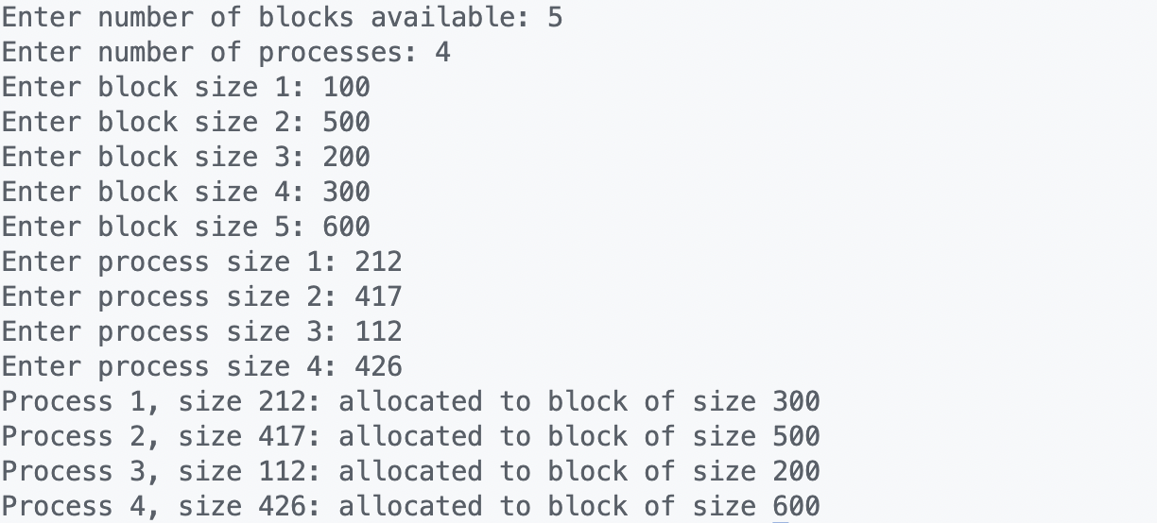

* Worst Fit

Code:

#include <iostream>

using namespace std;

void swap(int *x, int *y)

{

int temp = *x;

*x = *y;

*y = temp;

}

void sortDescending(int n, int *array)

{

int length = n;

for (int x = 0; x < length - 1; x++)

for (int y = x + 1; y < length; y++)

if (array[x] < array[y])

swap(array + x, array + y);

}

int main()

{

// getting input

int n, m;

cout << "Enter number of blocks available: ";

cin >> n;

cout << "Enter number of processes: ";

cin >> m;

int *block = new int[n], *process = new int[m];

for (int x = 0; x < n; x++)

{

cout << "Enter block size " << (x + 1) << ": ";

cin >> block[x];

}

for (int x = 0; x < m; x++)

{

cout << "Enter process size " << (x + 1) << ": ";

cin >> process[x];

}

bool assigned = false;

for (int x = 0; x < m; x++)

{

sortDescending(n, block);

assigned = false;

for (int y = 0; y < n; y++)

{

if (process[x] <= block[y])

{

cout << "Process " << (x + 1) << ", size " << process[x]

<< ": allocated to block of size " << block[y]

<< "\n";

block[y] -= process[x];

assigned = true;

break;

}

}

if (!assigned)

cout << "Process " << (x + 1) << ", size " << process[x] << ": Not allocated"

<< "\n";

}

}

Output:

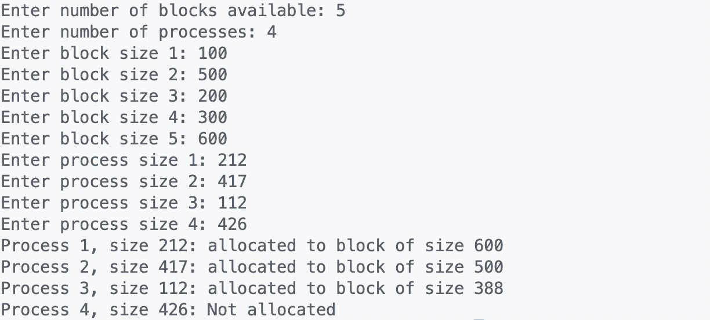

**Question 2**

#include <stdio.h>

#include <pthread.h>

void *threadProcess1(void *arg)

{

printf("Thread 1 starting...\n");

printf("Printing values 0 - 9\n");

for (int x = 0; x < 10; x++)

printf("%d\n", x);

printf("Thread 1 executed!\n");

return NULL;

}

void *threadProcess2(void *arg)

{

printf("Thread 2 starting...\n");

printf("Printing letters a - j\n");

for (int x = 97; x < 107; x++)

printf("%c\n", x);

printf("Thread 2 executed!\n");

return NULL;

}

int main()

{

pthread_t thread1, thread2;

pthread_create(&thread1, NULL, threadProcess1, NULL);

pthread_create(&thread2, NULL, threadProcess2, NULL);

pthread_join(thread1, NULL);

pthread_join(thread2, NULL);

}

Output:

